TASK 7

Three phase motor connected to Wye Delta starter controlled by stop and start push button station

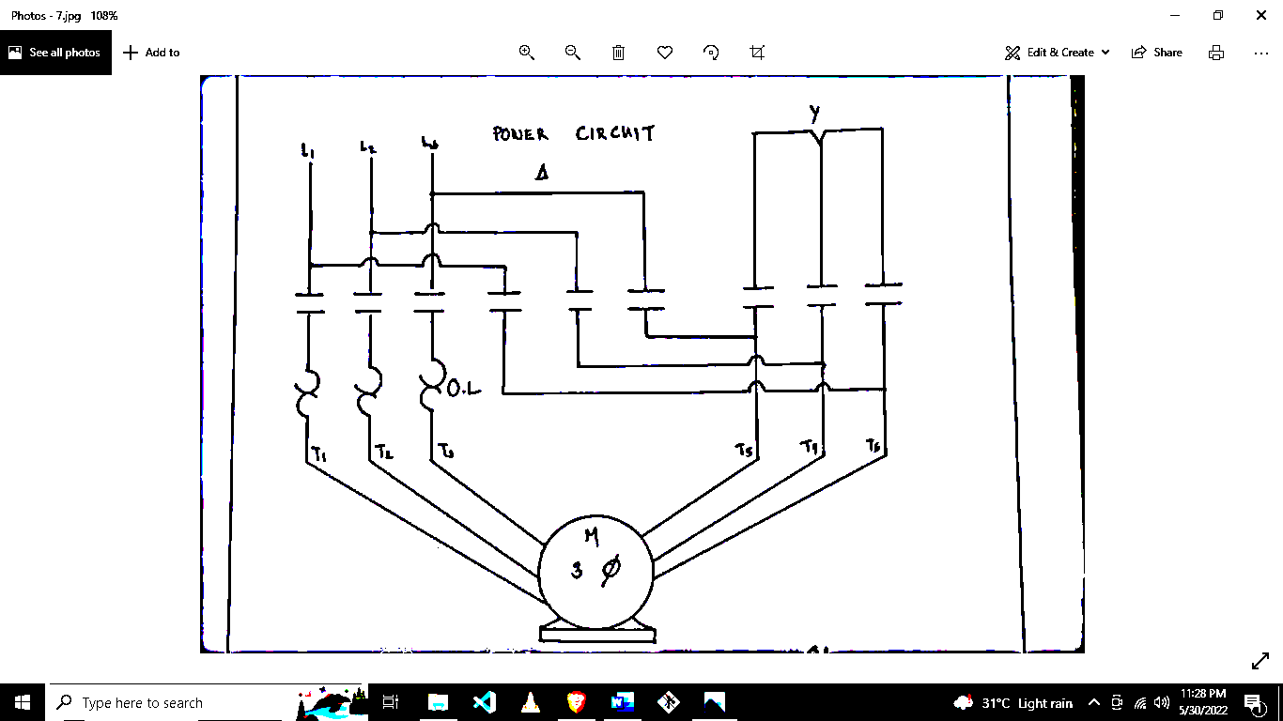

Instructor

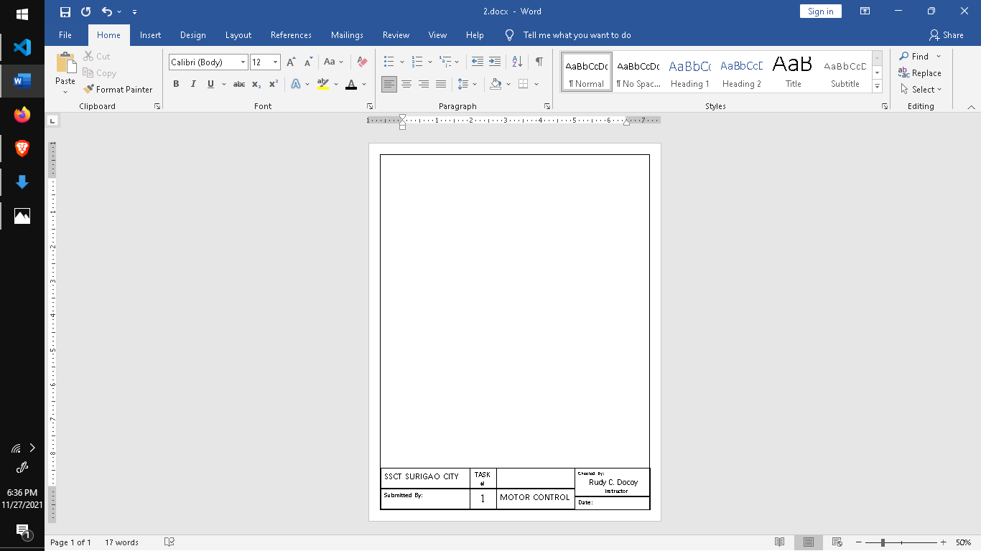



Checked By:

Rudy C. Docoy

MOTOR CONTROL

**Date :**May 31, 2022



TASK #

7

SSCT SURIGAO CITY

BEET 3C

Submitted By:

